2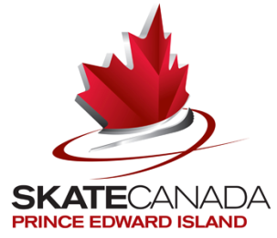

Off-Island Training – Summer 2022
(Must be postmarked by October 30, 2022)

Name:

Mailing address: City:

Postal Code: Telephone:

Date of Birth: Coaches name:
Day /month /year

Home Club: Skate Canada #:

Parent/Guardian: E-mail

Highest Assessments passed:
Skating skills Free Skate

Dance

Skaters training off-Island between June 15th and September 1st can receive funding of $200 per week for a minimum of 3 weeks and a maximum of 8 weeks. Skaters must have passed the complete STAR 3 FreeSkate Assessment by June 15 to be eligible for this funding.

NAME OF OFF-ISLAND SCHOOL ATTENDED | DATES | # OF WEEKS

Original receipts for registration or photocopies of front and back of cheque must accompany all applications for funding.
************************************************************************
Certification: I/We certify the above information to be true.

Parent’s signature Skater’s signature

Send to: Lynne Beairsto
beairsto@bellaliant.net

